BASIC SEGMENTED MODEL

* LL = Lower Lumbar Angles = LL segment to Pelvis segment
* UL = Upper Lumbar Angles = UL segment to LL segment
* LT = Lower Thoracic Angles = LT segment to UL segment
* UT = Upper Thoracic Angles = UT segment to LT segment
* Possibly Acromion segment as well -----

X = FRONTAL PLANE with + = Right Sidebending

Y = SAGITTAL PLANE with + = Flexion

Z = TRANSVERSE PLANE with + = Left Rotation

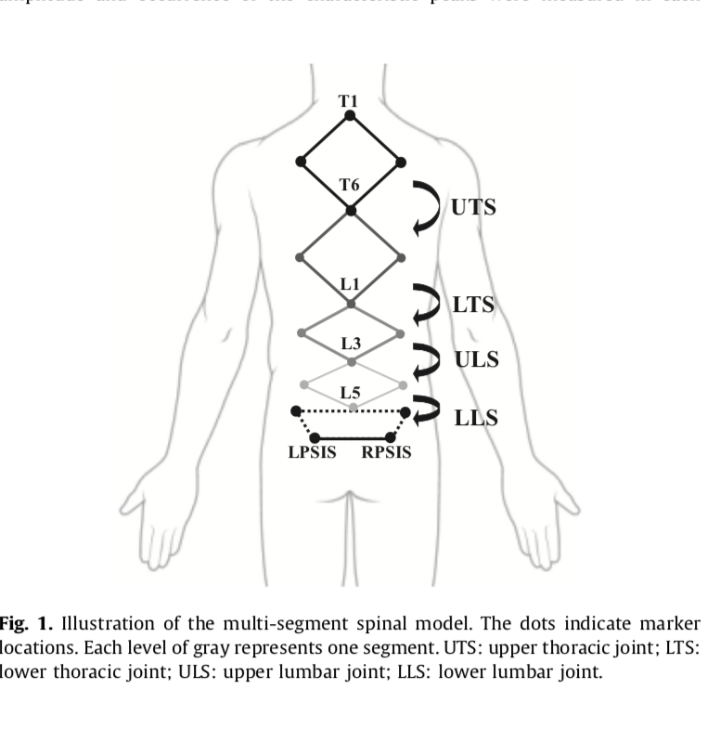

Angles of interest

|  |  |
| --- | --- |
| **Segment to Segment** | **Segment to LAB** |
| LL to Pelvis  UL to LL  LT to UL  UT to LT  AC to UT  UT to Pelvis  AC to Pelvis | LL to Pelvis  UL to LL  LT to UL  UT to LT  AC to UT  UT to Pelvis  AC to Pelvis |

* We use ANGLE as the measure of interest (in the three planes)
* Paper 1 used TOTAL range of motion
* Subsequent papers will use the DIFFERENCE between Right and Left Range of Motion = Asymmetry

**Methods used to date (June 2018) for analysis**

**SIDE BEND FILE. *(ROTATE FILE = SAME FORMAT)**

SBL1-2, SBR1-2 = Range of Motion (ROM) for side bend (SB) left (L), right (R) attempt 1, 2.

Absolute SBL/ SBR = Absolute values of SB trials.

[Absolute values used to calc all variables below]

Highest SB Left/ Right = Max of L1 vs L2. Max of R1 vs R2.

* These values were used for publication 1.

Mean SB Left/ Right = Average of L1,2. Average of R1, 2.

Asymmetry value 1 = Max Right – Max Left (Absolute values used)

Asymmetry value 2 = Average right – average left (absolute values used).

Total Range = Highest Right + Highest Left.

Range of Means = Average right + average left.

Asymmetry % 1 = Asymmetry Value 1/Total Range x 100.

Asymmetry % 2 = Asymmetry Value 2/ Range of means x 100.

Total Spine ROM = LL ROM + UL ROM + LT ROM + UT ROM (FRONTAL PLANE ONLY FOR SB. TRANSVERSE PLANE ONLY FOR SEATED ROTATION)

Segment contribution to total ROM = % of ROM attributed to each segment (e.g. LL ROM/ TOTAL SPINE ROM x 100).

**GAIT MAX MIN**

* **First values for gait have had the start position subtracted in Matlab.**

Gait Min = The minimum value for gait trial 1, 2.

Gait Max = The maximum value for gait trial for 1, 2.

Gait Min average = average lowest min value for trial 1 and 2.

Gait Max average = average max value for trial 1 and 2.

Gait total range (absolute) = Absolute min average + absolute max average.

Gait total range = max value – min value.

* This value was used for publication 1

Gait Asymmetry 1 =

Gait Asymmetry 2 =

Gait Asymmetry 3 =

Headings on files current processed by Chris June 2018

|  |
| --- |
| SBL1 |
| SBL2 |
| SBR1 |
| SBR2 |
| Absolute SB L1 |
| Absolute SB L2 |
| Absolute SB R1 |
| Absolute SB R2 |
| Highest SBL |
| Highest SBR |
| Mean Side Bend Left |
| Mean Side Bend Right |
| Asymmetry Value 1 (Highest Right - Highest Left) |
| Asymmetry Value 2 (Average Right - Average Left) |
| Total Range (Highest Right + Highest Left) |
| Range of Means (Average Right + Average Left) |
| Asymmetry Percentage 1 (Difference of Totals/Range of Totals)*100 |
| Asymmetry Percentage 2 (Difference of Means/Range of Means)*100 |
| Total Spine ROM |
| Segment Contribution |

TASKs

|  |  |
| --- | --- |
| **Tests** | **Ones in Red have NOT been processed by Karl** |
| Static Tests | Static Standing Posture |
| Static Seated Posture |
| Static one leg Weight Shift Posture |
| Movement tests | Standing Side bending |
| ~~Standing Rotation~~ (Data not valid) |
| Seated No Cues Rotation R and L |
| Seated No Cues Shear R and L |
| Seated Wobble Balanced  Rotation R and L |
| Seated Wobble Balanced  Shear R and L |
| Seated Wobble Hip Drop Right + Left  Rotation R and L |
| Seated Wobble Hip Drop Shear Right + Left |
| Standing Hip Drop with Thoracic Prop: Hip Drop R and L |
| Functional Tasks | Functional: Gait |
| Functional: Hurdle |
| Functional: Passe |
| Functional: Arabesque |